Name:____________________________________________________________

Class:_________________________ Date:___________________________

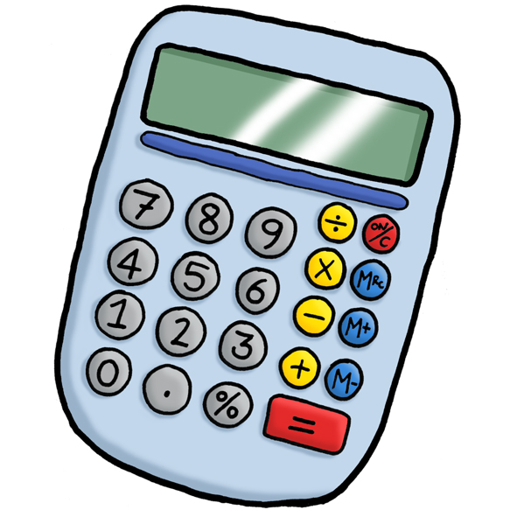
Objective: To solve problems where it may be necessary to do more than one calculation.

Parent Tip: Students should try and decide the best way to solve the problem. Where the numbers are large, or include a more challenging decimal, a calculator could be used.


1)A packet of crisps costs 35p.
How many packets could I buy with £3?

__________________________________________________________________

__________________________________________________________________

__________________________________________________________________

2)Mum is buying a loaf of bread (£1.10), some milk (96p), and a cake (£2.75) at the supermarket.
How much change will she get from a £10 note?

__________________________________________________________________

__________________________________________________________________

__________________________________________________________________

3)Iqbal gets £2.80 a week for pocket money. He is saving up for a computer game that costs £25.
How many weeks will he have to wait before he can buy it?

__________________________________________________________________

__________________________________________________________________

__________________________________________________________________

4)David has bought a 5 m roll of tape. He wraps two presents using 2.36 m and 84 cm of the tape.
How much has he got left?

__________________________________________________________________

__________________________________________________________________

__________________________________________________________________

5) Fill in the missing numbers:

a) 297 + = 524 b) – 15 = 38

c) 24 × = 264 d) 12 ÷ 1.5 =

6) Look at the entrance charges to the Adventure Park:
Entrance Prices
Adult £7.50
Child £3.25

Ali is going to the park with his two sisters and his mum and dad.
How much will it cost?

______________________________________________________________

7) Amy is going on holiday and needs to buy some Euros.
Exchange Rate
£1 buys | 1.42 Euros

a) How many Euros will she get for £10?

______________________________________________________________

b) How many Euros will she get for £14?

______________________________________________________________

