Name:

Class: Date:

Objective: Understand subtraction as 'take away' and find a 'difference' by counting up; use practical and informal written methods.

A good way of subtracting is to find the difference between two numbers by counting up or back from one to the other on a number line like this.
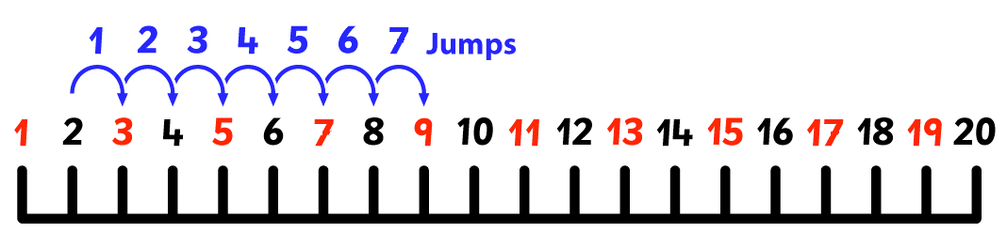

The difference between 2 and 9 is 7.

9 take away 2 equals 7.

9 – 2 = 7

Use the number line to help you complete these subtraction sentences.

1) 2)
a) The difference between a) The difference between
5 and 8 is ______ 3 and 7 is ______
b) 8 take away 5 equals ______ b) 7 take away 3 equals ______
c) 8 – 5 = ______ c) 7 – 3 = ______

3)
a) The difference between
5 and 14 is ______
b) 14 take away 5 equals ______
c) 14 – 5 = ______
4)
a) The difference between
9 and 17 is ______
b) 17 take away 9 equals ______
c) 17 – 9 = ______

5)
a) The difference between
8 and 15 is ______
b) 15 take away 8 equals ______
c) 15 – 8 = ______

6)
a) The difference between
19 and 10 is ______
b) 19 take away 10 equals _____
c) 19 – 10 = ______

Now put the numbers in by yourself.

7) The difference between
6 and 18 is ______
____ take away ____ equals ____
______ – ______ = ______
8) The difference between
5 and 16 is ______
____ take away ____ equals ____
______ – ______ = ______

