Note for adults
Help your child to understand how to break the story into scenes and how to describe the scenes clearly.

Play scenes
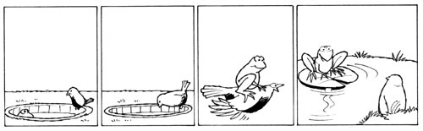
- Divide the story of the Little Green Frog into scenes.

Scene 1

Description (where): The bottom of a well. It is cool and damp, with insects flying around.

Characters (who): A frog sits looking happily at the sky.

Action (what happens): A bird comes and peers over the edge of the well and talks to the frog.

Scene 2

Description (where): At the top of the well.

Characters (who):

Action (what happens):

Scene 3

Description (where): At the top of the well.

Characters (who):

Action (what happens):

Scene 4

Description (where): At the top of the well.

Characters (who):

Action (what happens):

