4 Friction

Activity 1

Lara and Jim investigated wind-up cars over different surfaces.

Here are Lara’s results:
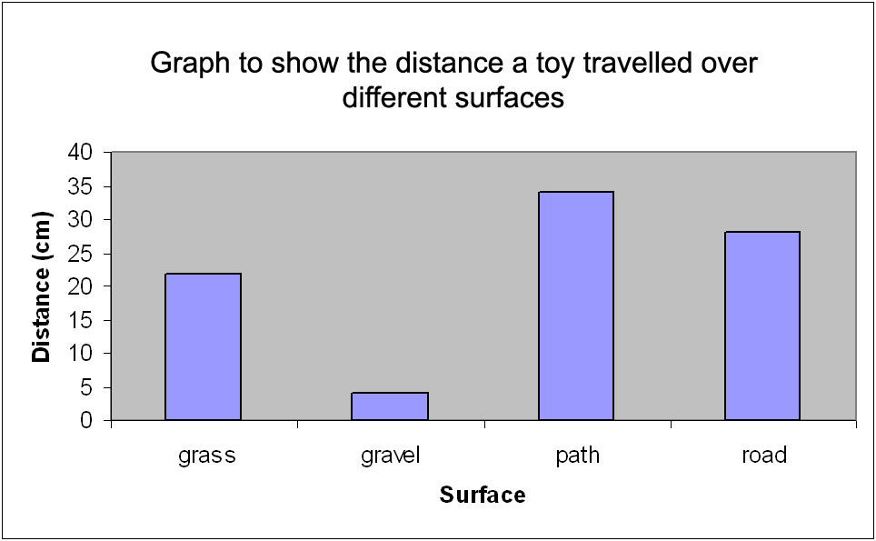

Over which surface did the car travel the furthest distance?

Over which surface did the car travel the shortest distance?

When Jim did the same investigation, he got the following results:
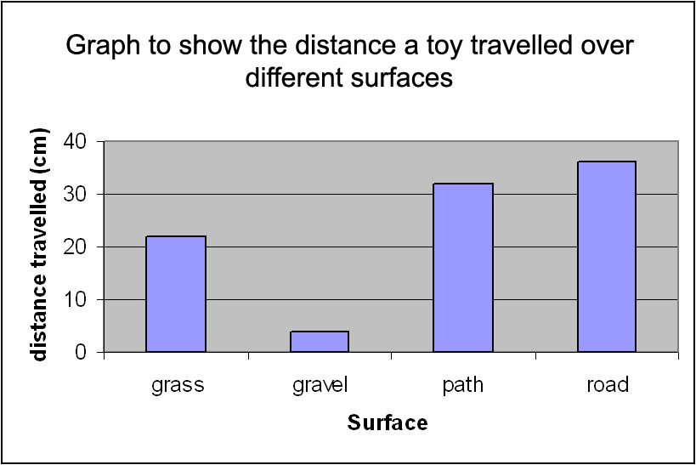

Over which surface did the car travel the furthest distance?

Over which surface did the car travel the shortest distance?

Can you think of a reason why they did not get the same results?

What force caused by the surface slowed the cars down?

Looking at both Jim and Lara’s results, which surface do you think has the most friction? Explain your answer.

Challenge Finding out about friction between a surface and an object

You will need:
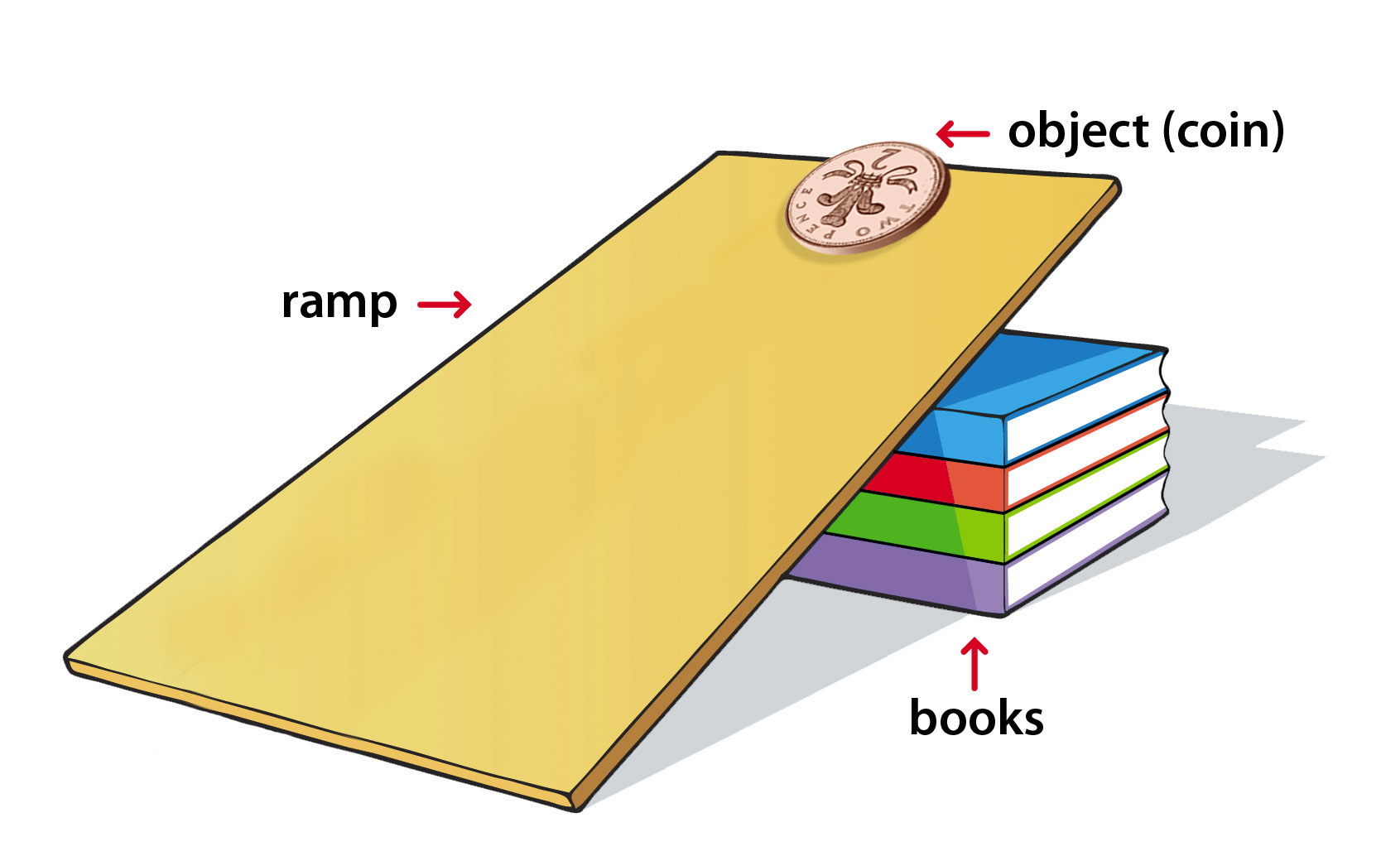
- A piece of cardboard
- Books
- A coin
- A rubber
- A pen
- An ice cube
- Other objects
- A ruler

Method:

- Place the piece of cardboard on the books so that it forms a ramp.
- Place the objects at the top of the cardboard.
- Use the ruler to stop them falling.
- Take the ruler away and watch what happens.

Which objects fall most quickly?

Can you explain why this happens?

